Effect of Rigid Bar Attached at Ends to McKibben Mesh

Purpose
Investigate the boundary between the free McKibben muscle (MKM) and constrained MKM regions. Identify system constraining factors.

Materials
- 5x 200mm Long Polyester Mesh, ¼” relaxed 7/16” expanded https://www.mcmaster.com/9284k612/
- 5x White long balloons
- Small zip ties

Procedure
Printed plastic structures centered on the length of the MKM mesh & attached at either end:
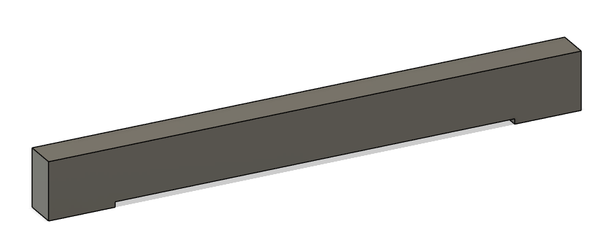
Muscle # | Overall Length (mm) | Plastic Length (mm) | Plastic Height - No Attachment Region (mm) | Plastic Width (mm) | Attachment Region Length (mm)
1 | 200 | 40 | 4 | 2.5 | 5
2 | 200 | 65 | 4 | 2.5 | 5
3 | 200 | 80 | 4 | 2.5 | 5
4 | 200 | 95 | 4 | 2.5 | 5
5 | 200 | 110 | 4 | 2.5 | 5

Inserted balloon through mesh, tied distal end of balloon, and zip-tied distal end of balloon and mesh together tightly.
Attached proximal end of balloon to air gun with a zip tie and inflated balloon. Observed MKM deformation.

Deviations
- Printer crashed when printing first 65mm mesh. Upon re-leveling the bed, the printer made too much contact with the mesh, causing the entire bar to attach to the mesh. Thus, the 110mm bar was made on PEEK mesh (https://www.mcmaster.com/2656k11/).

Results
Muscles had piecewise behavior with boundary regions. Most noticeable in the longest tested print (110 mm bar), the muscle when inflated was straight and expanded leading to the bar-included region, then it bent in the boundary region before becoming straight and not expanded, then it bent again at the second boundary before becoming straight and expanded again. The muscle seems to not be able to expand where the rigid bar is included because to do so it needs to press the bar away from the muscle, which it can’t do. To test this, I will make bars that have rigid members which move away from the muscle, giving it room to expand without hitting the bar.

